

Benefits Team 1

February 29, 2024| VA Benefits Letters 1.0

Revision History

| Date | Version | Description | Author |
| --- | --- | --- | --- |
| 2/29/2024 | 1 | Product Guide First Draft | Jacob Worrell |

Table of Contents

Table of Contents 3

1. VA Benefits Letters Overview 4

2. User Access 4

3. Navigation 4

3.1 To application from homepage 4

3.2 Using main menu navigation 6

4. Functionality 6

4.1 Changing address information 6

4.2 Viewing and downloading letters 8

5.1 Letter fails to download when user clicks “download” button 12

5.2 Application fails to load or times out 12

## 1. VA Benefits Letters Overview

The VA Benefits Letters section of VA.gov is a place where Veterans can access and download their VA Benefit Summary Letter (sometimes called a VA award letter) and other benefit letters and documents online. Important to note, this product is different from the claim letters (decision letter download) feature in the Claim Status Tool (CST).

## 2. User Access

Users will need to be logged into the site and be eligible for VA benefits.

## 3. Navigation

**Direct URL: https://va.gov/records/download-va-letters/**

### 3.1 To application from homepage

Users starting from the homepage can first click on Records.

From the “Records” landing page, users can then click on the “Download Your VA Benefits Letters” link.

Next, the user can click the “Get Your VA benefits letters” link.

### 3.2 Using main menu navigation

Alternatively, the user can use the top menu navigation: VA Benefits and Health Care > Records > Download your VA Benefits Letters

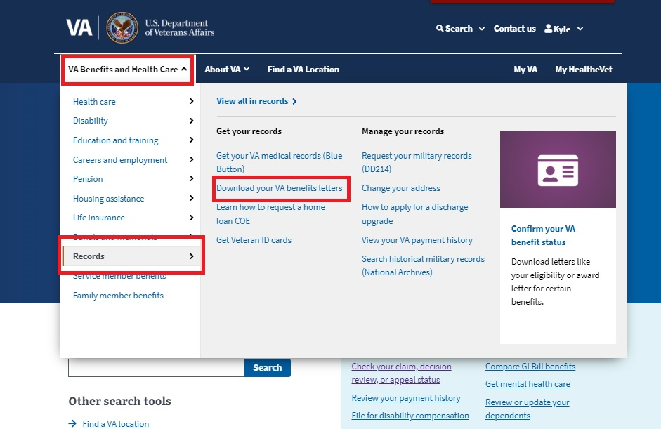

## 4. Functionality

### 4.1 Changing address information

From the first screen of the VA Benefits Letters application, the user will be invited review their address information. It’s important for the user to do so because their address information will appear directly on the documents the application will later generate.

To edit the address information, the user must click “edit”

If the user opts to change their address, they must ensure they put values in the required fields. When they are finished making their revisions, they should click “save”.

### 4.2 Viewing and downloading letters

From the first screen in the application, user should click “View Letters”

The user will then see a screen with instructions on how to use the application to download letters. They will see an accordion (the sections with the “+” icon) for each letter type available. By clicking the “+” icon, the section will expand.

In the expanded section, there should be a “Download” button, which will enable the user to download a document as a .pdf file.

Once the document is successfully generated and downloaded the user will be provided a confirmation message. The user can find their file in the “Downloads” section of their web browser.

## 5. Major Issues and Error Messages

### 5.1 Letter fails to download when user clicks “download” button

In the case that a particular letter fails to download, instead of the confirmation message, the user will be provided an error alert prompting them that something has gone wrong. This can occur due to one of the upstream services that provides the information being temporarily unavailable or due to application downtime. When this occurs, it is best for the user to wait 1-2 hours and then try again.

### 5.2 Application fails to load or times out

There are also some cases in which the entire application itself fails to load or times out. The user may be presented with an error message saying the application failed or the application may simply never present the content. In both cases, the user will likely try and refresh the page in their browser and sometimes that will resolve the issue. If the application fails to load after repeated attempts at reloading, there could be a service issue affecting all of VA.gov or a service upstream to the application preventing the application to load. In these cases, the user is advised to wait 1-2 hours before trying again.